Jetnet – May 13

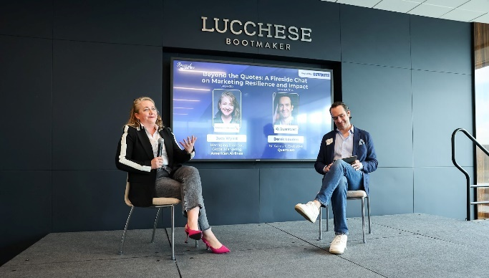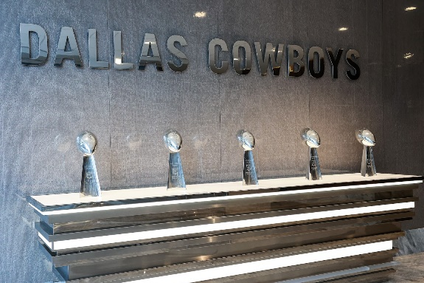

Jacs Wyatt highlights power of leadership at top industry summit

Some of the brightest minds in marketing strategy gathered recently at The Star in Frisco, Texas — home of the Dallas Cowboys — for the Brand Innovators Sports, Media and Entertainment Summit. The event brought together global leaders like Nike, PepsiCo, Amazon and Google alongside emerging disruptors. For American, it was a chance to connect with pioneers across industries and think differently about how to engage customers and lead teams.

Representing American, Jacs Wyatt, Managing Director of Global Marketing, stood out for more than the airline’s bold creative campaigns. Her session offered a compelling take on leadership and resilience — both in marketing and in people management.

Wyatt structured her session around three iconic sports quotes, drawing from Jim Valvano, Vince Lombardi and Michael Jordan. “Don’t give up on yourself, and don’t give up on the power of connection,” she told a packed room, echoing Valvano. “Resilience isn’t about going it alone. It’s about believing in your value and knowing when to collaborate, when to listen and when to lead.”

She shared how strong, intentional leadership unlocks better collaboration across teams and disciplines, allowing bold ideas to take flight. She spotlighted how American’s marketing organization is breaking new ground, not just in storytelling and marketing innovation, but in how teams are empowered and aligned.

Quoting Lombardi, she added, “If we chase perfection, we can catch excellence.” Jacs encouraged leaders to act like business owners, embrace challenges and course correct in real time — skills that are just as essential in leading people as in launching campaigns.

Her message resonates far beyond marketing teams. “I’ve failed over and over again, and that’s why I succeed,” she said, quoting Jordan. “Failure isn’t the opposite of success, it’s the foundation of it.”

With American recently announced as the Official Airline of U.S. Soccer and the Official North American Airline Supplier for the FIFA World Cup 2026™, Jacs was a popular source for questions and advice on leadership in the evolving intersection of brand, culture and sport.

This story launches a new internal series spotlighting exceptional people leaders across American — those shaping the future of our business with vision, creativity and courage.

